For Immediate Release
RetroLiner from Bedwood and Parts
Bedwood and Parts, LLC has developed a truly innovative product to deliver yesteryear’s classic touch for all light trucks – from 2010 domestic and import models back though the muscle car era (including El Caminos, Rancheros, etc.) to the pre-war classics– the RetroLiner™ wood bed liner system. The RetroLiner wood bed liner system is designed for Pickups, plus SUVs and Crossovers with steel beds or floors.
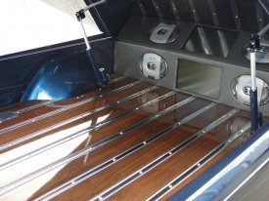
The RetroLiner™ system is a complete package containing all of the required materials needed to make the installation without damage to the factory steel bed. Bedwood and Parts uses state-of-the-art computer aided design (CAD), 3-D modeling and digital measurement procedures to assure a precision fit. Each RetroLiner™ system package installs with a single tool (contained in each kit) and requires no cutting or drilling.
Each RetroLiner™ kit is available in nearly forty (40) popular and exotic wood species, for over 200 OE applications, and custom applications are virtually endless. Each wood piece is kiln dried and stabilized, pre-cut, properly milled, grooved, 4-stage finish sanded and delivered ready to finish. In addition to the wood, every kit includes cut-to-length polished stainless steel bed strips, stainless steel mounting hardware, mounting pads, subframe and installation tool. Each kit has comprehensive, easy-to-follow instructions which include tips for care and treatment of the wood.
For more information, contact sales@bedwoodandparts.com or 270 424 3000.
Bed Wood and Parts • 8345 Madisonville Road • Hopkinsville, KY 42240
270.424.3000 • www.bedwoodandparts.com

