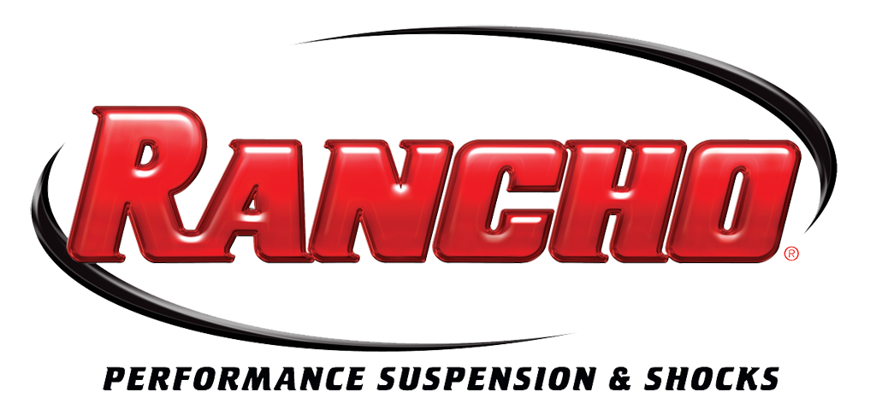
For More Info:
Christine Bowser, Pinnacle Media
(330) 688-3515, chrissy@pinnmedia.com

FOR IMMEDIATE RELEASE

NEW RANCHO® TORSION KEY SYSTEMS AVAILABLE FOR
CHEVROLET/GMC SILVERADO/SIERRA 1500, 2500/3500HD TRUCKS

Las Vegas, NV, Oct. 30, 2012 – Tenneco’s Rancho® brand of performance suspension and shock absorbers has recently added Rancho® torsion key systems for Chevrolet/GMC Silverado/Sierra 1500, 2500HD and 3500HD trucks to its product line.
Designed to level the truck’s stance, Rancho torsion key systems are a fast and easy way to add 1 to 2-1/4-inches of lift over stock. The new kits allow the truck owner to clear up to 33-in. tires and help compensate in instances where there is added front-end weight such as snow plows, heavy-duty bumpers or winches.
Each system includes a forged Level IT torsion key that is stronger than OE, maintains the factory ride and is easily installed through direct, bolt-on assembly.
“These new systems include a set of precisely engineered RS5000 shocks to sustain the demands of a larger tire and wheel package and to help level the vehicle,” said Chris Gauss, national sales manager, performance brands, Tenneco. “That’s an advantage that clearly differentiates Rancho from other manufacturers who use spacers and blocks.”
Rancho torsion key systems include a set of extended length Rancho® RS5000® front shocks that allow the shocks to maintain the proper OE position without the use of extended shock brackets or a spacer kit, allowing for better control and improved ride quality over spacers or brackets.
Available early in 2013 at performance retailers nationwide, Rancho torsion key systems are available for the following truck models:
- 1999-2007 Chevrolet/GMC Silverado/Sierra 1500 4WD (RS66300R5)
- 2001-2010 Chevrolet/GMC Silverado/Sierra 2500/3500HD (RS66350R5)
- 2011-2013 Chevrolet/GMC Silverado/Sierra 2500/3500HD (RS66351R5)
The torsion key systems are backed by the Rancho brand’s limited lifetime warranty, see www.GoRancho.com for additional details.
For more information regarding the Rancho torsion key systems and other advanced ride control components for off-road and performance use, please visit www.GoRancho.com, contact your nearest Rancho dealer or call 1-734-384-7806. To locate your nearest Rancho authorized dealer, please use the “Where to Buy” tab at www.GoRancho.com to generate a list of nearby stores in your selected regional and other online retailers.
The Rancho suspension and shocks brand is one of the performance aftermarket’s leading brands. The Rancho brand of performance suspension and shock absorbers is manufactured and marketed by Tenneco (NYSE: TEN) and headquartered in Long Beach, Calif.
Tenneco is a $7.2 billion global manufacturing company with headquarters in Lake Forest, Illinois and approximately 24,000 employees worldwide. Tenneco is one of the world’s largest designers, manufacturers and marketers of emission control and ride control products and systems for the automotive and commercial vehicle original equipment markets and the aftermarket. Tenneco markets its products principally under the Monroe®, Walker® and Clevite® Elastomer brand names.
###

