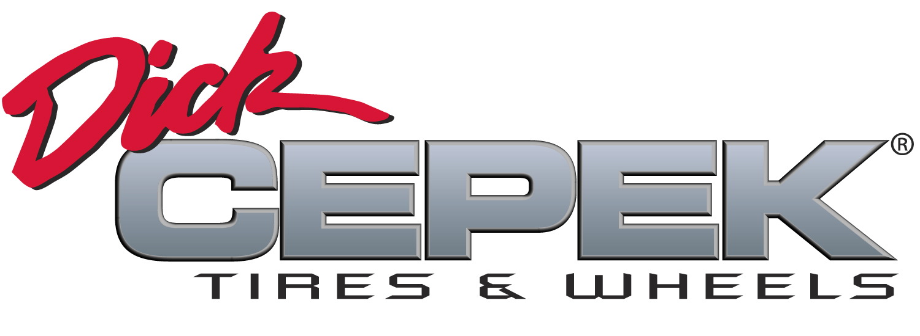
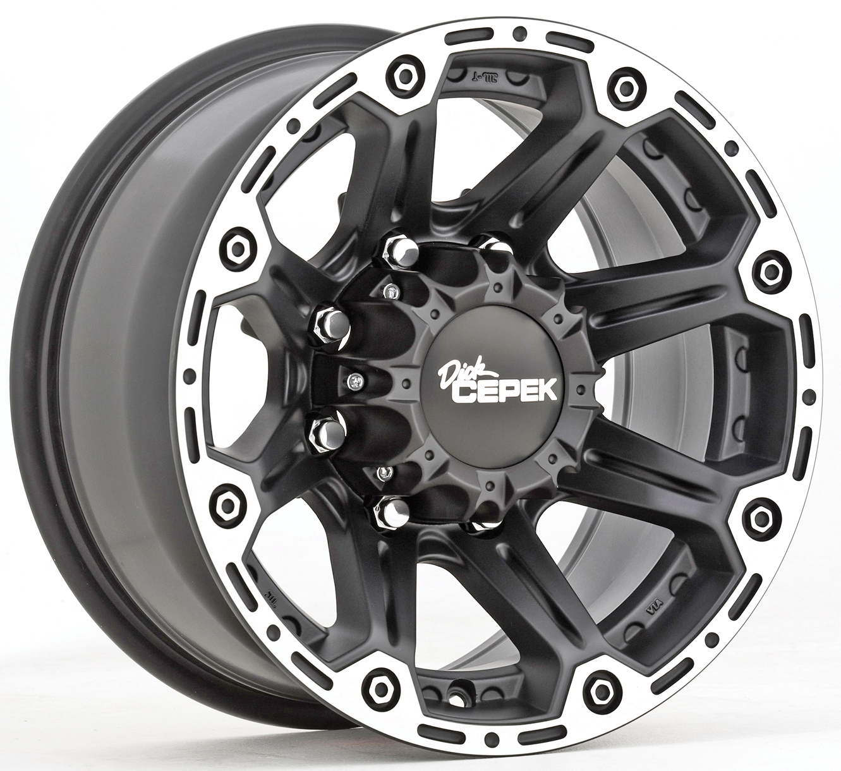

Contact :

DICK CEPEK TIRES
& WHEELS
4600 Prosper Drive
Stow, OH 44224
Don Sneddon, Advertising Manager
800-222-9092 ext. 3750
or 330-928-9092
www.dickcepek.com

DICK CEPEK® TIRES & WHEELS OFFERS THE TORQUE WHEEL

STOW, OH – The Torque wheel from Dick Cepek Tires & Wheels is a high-offset machined aluminum wheel that has been specially designed for newer trucks and SUV’s that require a higher offset, additional brake caliper clearance and the ability to use the factory Tire Pressure Monitoring Sensors (TPMS). Available in 16- to 20-inch sizes, the Torque features a machined outer lip, unique flat black finish, and a satin clear coat, and coordinating center cap for ultimate style and durability.

“This unique eight-spoke wheel combines a number of important benefits for today’s trucks and SUV’s,” stated Ken Warner, VP Sales & Marketing, Dick Cepek Tires & Wheels. “This wheel offers the perfect combination of style and function for the truck owner that needs a tough wheel that looks great and is easy to care for.”

The Torque wheel is the perfect choice for the truck owner that wants to combine style with function. For more information, visit http://www.dickcepek.com/wheels.php.

About Dick Cepek Tires & Wheels
Founded in 1963 by off-road enthusiast Dick Cepek, the Dick Cepek brand has always taken great pride in providing quality on and off-road products for truck, SUV and 4x4 owners. From its humble beginnings to its high-tech tire manufacturing facilities around the country today, the Dick Cepek legend lives on in the quality products that bear his name. For more information, visit http://www.dickcepek.com

