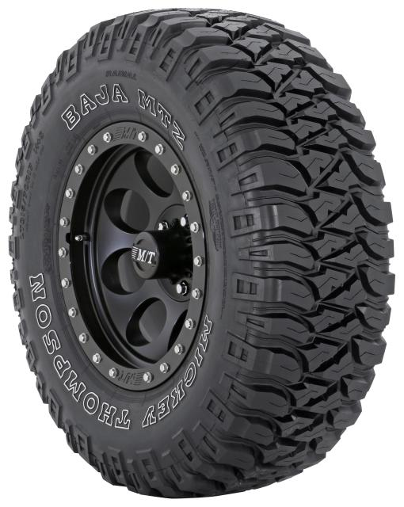

Contact :
MICKEY THOMPSON
PERFORMANCE TIRES & WHEELS
4600 Prosper Drive
Stow, OH 44224
Don Sneddon, Advertising Manager
800-222-9092 ext. 3750
dsneddon@mickeythompsontires.com
http://www.mickeythompsontires.com/

MICKEY THOMPSON PERFORMANCE TIRES & WHEELS
INTRODUCES NEW LOAD RANGE E SIZES FOR BAJA MTZ

STOW, OH – Mickey Thompson Performance Tires & Wheels has added four new load range E sizes to the popular Baja MTZ line including LT285/75R16, LT305/70R16, LT315/75R16 and LT285/70R17.

“The Baja MTZ is our most versatile off-road tire,” stated Ken Warner, VP Sales & Marketing, Mickey Thompson Performance Tires & Wheels. “We’ve added several popular light truck sizes to the line with a higher load ratings, so it’s a great choice for ¾-ton and one-ton pickup owners who haul heavy loads or a trailer, including work truck owners.”

The Baja MTZ’s PowerPly™ sidewalls and Sidebiters® on the sidewall offer high-performance handling and puncture resistance. The self-cleaning, high-void tread lugs and deep shoulder lugs provide aggressive traction in off-road applications. For more information visit http://www.mickeythompsontires.com/BajaMTZRadial. To find a dealer near you, visit http://www.mickeythompsontires.com/dealerlocator.

About Mickey Thompson Performance Tires & Wheels
Max-Trac Tire Co., Inc., dba Mickey Thompson Performance Tires & Wheels, markets racing and high-performance tires and wheels for street, strip, truck, and off-road applications. The company was founded in 1963 by racing legend Mickey Thompson and is headquartered in Stow, Ohio, USA. For more information, visit http:/www.mickeythompsontires.com/.

