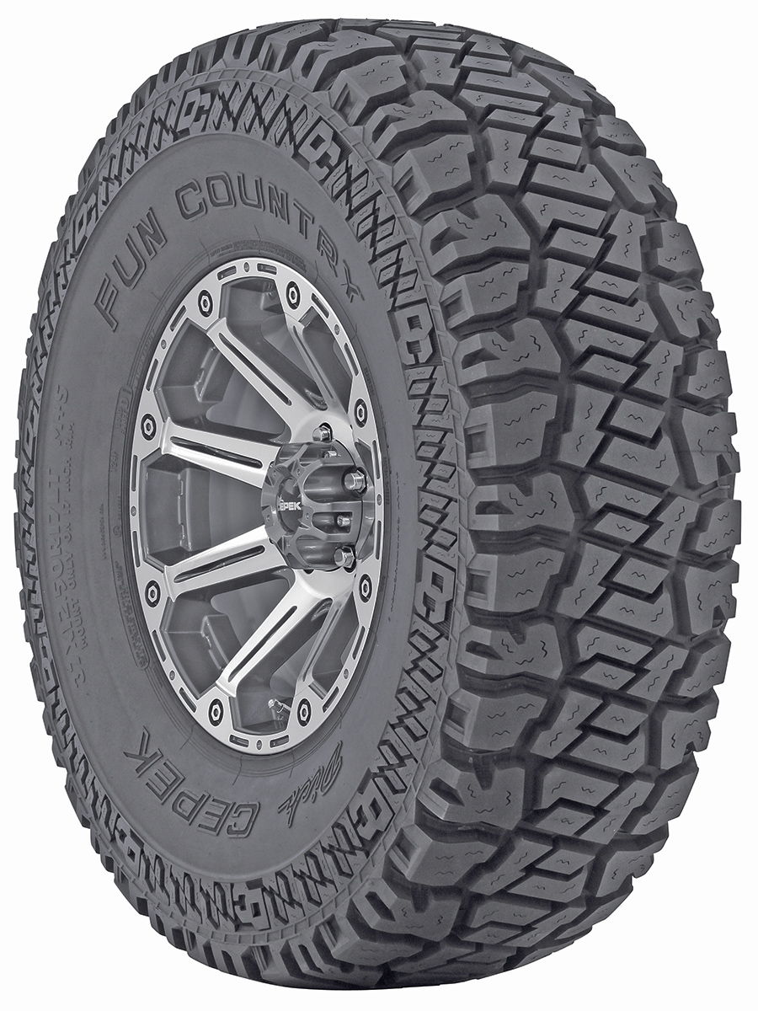

Contact :

DICK CEPEK TIRES
& WHEELS
4600 Prosper Drive
Stow, OH 44224
Don Sneddon, Advertising Manager
800-222-9092 ext. 3750
or 330-928-9092
www.dickcepek.com

DICK CEPEK® TIRES & WHEELS OFFERS 12 NEW FUN COUNTRY RADIAL SIZES

STOW, OH – May 17, 2013 – Dick Cepek now offers 12 new sizes of the Fun Country radial. With a unique hybrid design, the completely redesigned Fun Country is one of the most impressive all-terrain tires in the history of the Dick Cepek line.

Wide lateral and offset tread grooves together with the larger surface area deliver excellent grip and responsive off-road traction. Stone ejector ribs and ultra-thin sipes resist stone retention and cracking. Notched shoulder edges, scalloped ribs and the enhanced buttress maximize off-road traction and prevent lug tearing, and the three-ply sidewall makes it extra tough. Computer optimized pitch sequence in the tread design reduces pattern noise for a quieter ride and even wear.

“The new Fun Country is unlike any Dick Cepek tire that has come before it,” stated Ken Warner, VP of Marketing, Dick Cepek Tires & Wheels. “This tire is a unique combination of cutting-edge design elements and technology that give new meaning to the all-terrain category. We have dedicated attention to every aspect of the design process - footprint, tread, lugs, siping, shoulder, tire compounds and appearance – to make this one of the best tires Dick Cepek has ever made.”

The Fun Country is a 2012 SEMA Global Media Award winner. For more information and a full list of available sizes, visit http://www.dickcepek.com/tires.php?item=FunCountry.

About Dick Cepek Tires & Wheels
Founded in 1963 by off-road enthusiast Dick Cepek, the Dick Cepek brand has always taken great pride in providing quality on and off-road products for truck, SUV and 4x4 owners. From its humble beginnings to its high-tech tire manufacturing facilities around the country today, the Dick Cepek legend lives on in the quality products that bear his name. For more information, visit http://www.dickcepek.com
*Chart, page 2.

