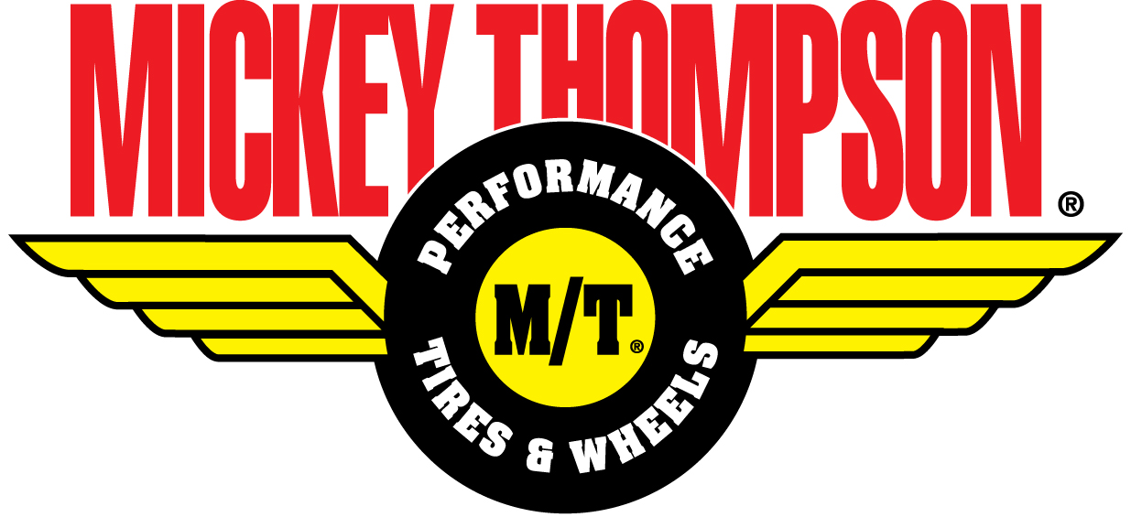
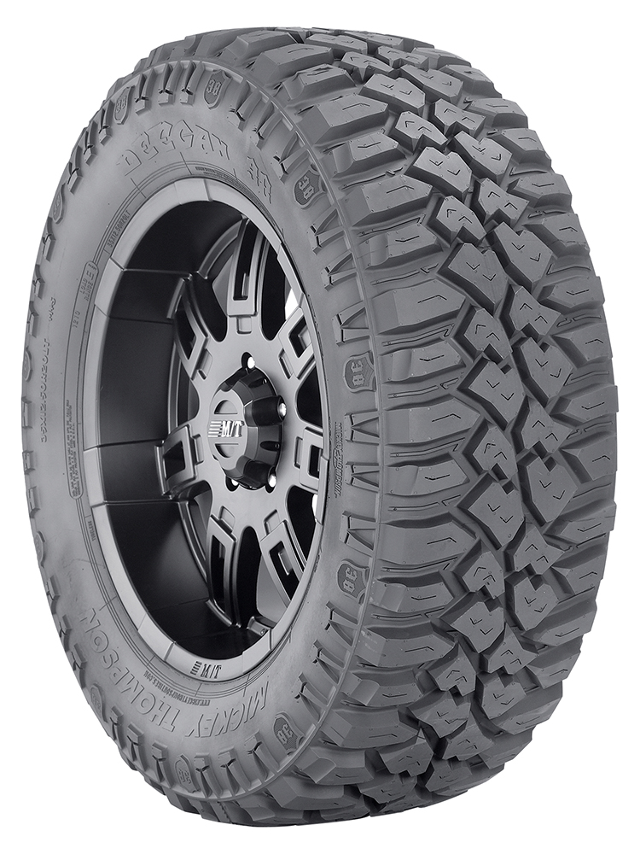

Contact:
MICKEY THOMPSON
PERFORMANCE TIRES & WHEELS
4600 Prosper Drive
Stow, OH 44224
Don Sneddon, Advertising Manager
800-222-9092, 330-928-9092 ext. 3750
dsneddon@mickeythompsontires.com
http://www.mickeythompsontires.com/

MICKEY THOMPSON PERFORMANCE TIRES & WHEELS INTRODUCES DEEGAN 38 LIGHT TRUCK TIRE

STOW, OH – Oct. 29 – Mickey Thompson Performance Tires & Wheels (Mickey Thompson) has introduced an innovative new light truck tire. Developed with five-time Lucas Oil Off Road Racing Series (LOORRS) champion and 16-time X Games medalist Brian Deegan, the Deegan 38 is the ultimate mud-terrain tire delivering aggressive performance, respectable street manners and impressive style.

The tread consists of Mickey Thompson’s proven compound and a number of unique design elements: The beveled tread edge enhances stone ejection and lug integrity; special wide lateral and offset grooves channel water away and handle mud and rocky terrain; and large center tread elements deliver better grip, even wear and a quieter ride; stone ejector ribs eject stones, dirt
and mud.

Along the shoulder, Mickey Thompson’s signature SideBiters® and unique shoulder scallops guide mud and loose soil away from the tread in both forward and reverse. The enhanced sidewall design includes high tensile body ply cord for increased sidewall integrity, reduced rolling resistance
and heat buildup. The tire’s sidewall depicts a Deegan 38 shield and stylized raised white
block lettering.

"I am honored to have the opportunity to partner with the company whose roots go back to the beginnings of short course racing,” stated Deegan. “Mickey Thompson is an iconic brand in the off-road world, and having the opportunity to develop the Deegan 38 line with Mickey Thompson is another major step in carrying on the deep tradition of the Mickey Thompson brand."

“Product innovation is part of our 50-year legacy, and we’ve worked with Brian, a champion competitor, to develop a new product with trusted Mickey Thompson quality and performance,” stated Ken Warner, VP of marketing, Mickey Thompson. “The Deegan 38 offers a truly unique mud terrain tire with long tread life, versatility and rugged appearance for demanding enthusiasts.”

Proudly made in the USA, the Deegan 38 is scheduled for availability in the second quarter of 2014, and will be introduced in 13 popular sizes. For more information, visit http://www.deegan38tires.com.

-more-
About Brian “The General” Deegan
A professional racer since age 17, Brian Deegan is now one of today’s most decorated action sports athletes, and co-founder of Metal Mulisha. He is an international competitor and the most decorated Freestyle Motocross rider in the competition’s history having earned 16 X Games medals including a gold medal in X Games 17, and a bronze medal in X Games 18, both in RallyCross. He continues to test the limits in Freestyle Motocross, Pro 2 and Pro Lite Short Course racing, RallyCross, and Stock Car racing. In 2012, he earned the LOORRS Pro 2 Class Championship, and placed second in the 2012 inaugural season of the Global RallyCross series. In 2011, he earned the LOORRS Pro 2 and Pro Lite Class Championships and was honored as Pro 2 Rookie of the Year. That same year, he was one of only two drivers to represent the USA at the Race of Champions in Germany. Major sponsors include Rockstar Energy Drink, Ford Motor Company, Mickey Thompson Performance Tires & Wheels, Metal Mulisha, FRAM Filtration, DVS Shoe Co., Lucas Oil, Makita Industrial Power Tools, MSR, Gibson Exhaust Systems, 4-Wheel Parts, Motegi Wheels, Ronin-Syndicate, Atomik R/C, Pro Taper, MYPLASH Prepaid MasterCard, Fathead, Brembo, Fortin, PPG, VP Racing Fuels, Fox Shocks, Impact by Mastercraft Safety, MSD Ignitions, FK Rod Ends, California Torque Products, Eibach Springs, McKenzies, Fiberwerx, JE Pistons, QTM, Roush Yates Engines, G2, Dailey Engineering, Brown & Miller Racing Solutions, ARP, Replay and AZ Driveshafts. For more information, visit http://www.briandeegan.com/.

About Mickey Thompson Performance Tires & Wheels
Max-Trac Tire Co., Inc., dba Mickey Thompson Performance Tires & Wheels, markets racing and high-performance tires and wheels for street, strip, truck, and off-road applications. The company was founded in 1963 by racing legend Mickey Thompson and is headquartered in Stow, Ohio, USA. For more information, visit http:/www.mickeythompsontires.com/, http://www.mickeythompsontires.com/about.php.

