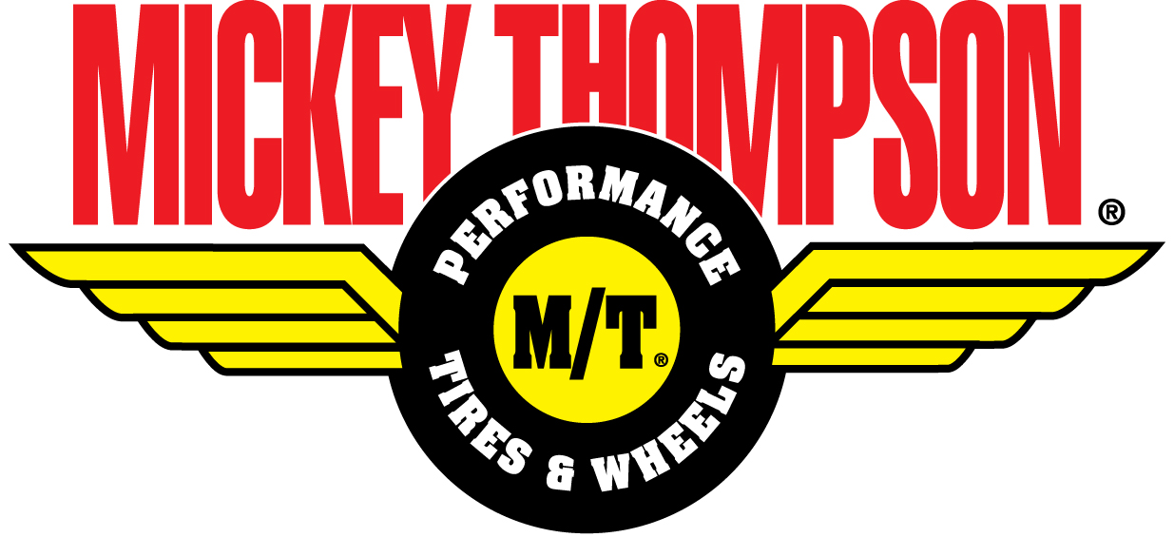Contact :
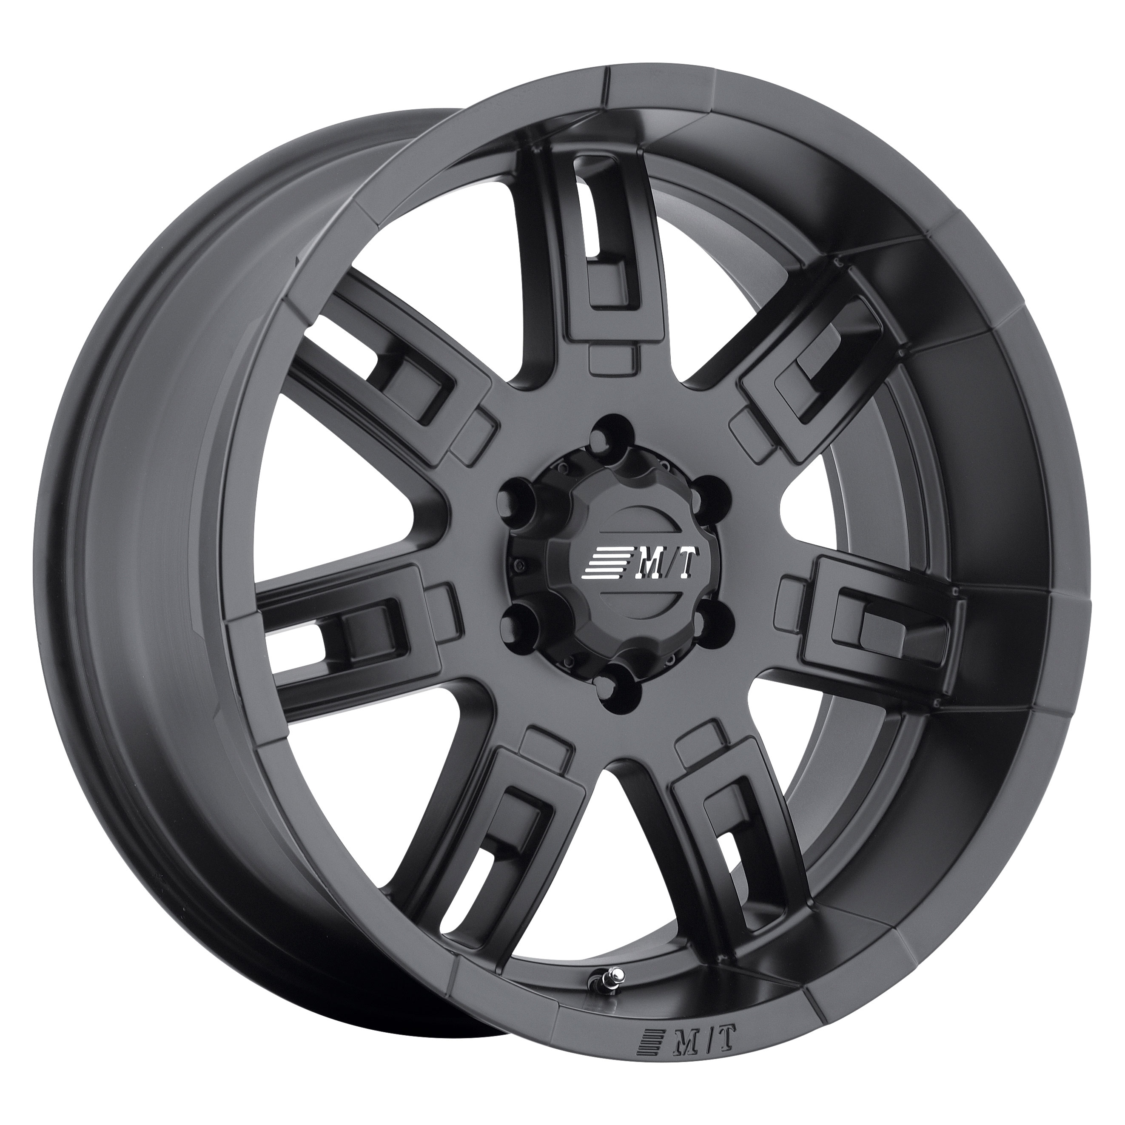
MICKEY THOMPSON
PERFORMANCE TIRES & WHEELS
4600 Prosper Drive
Stow, OH 44224
Don Sneddon, Advertising Manager
800-222-9092 ext. 3750
or 330-928-9092
dsneddon@mickeythompsontires.com
http://www.mickeythompsontires.com/

MICKEY THOMPSON PERFORMANCE TIRES & WHEELS INTRODUCES THE SIDEBITER® II WHEEL

STOW, OH –The SideBiter II Wheel is one of several new additions to Mickey Thompson’s impressive wheel line. This tough, stylish wheel features the signature “SideBiter” styling, a durable satin black finish, a seven-spoke design, and a new “pop-top” center with embossed center cap featuring the Mickey Thompson logo. Available in popular 15-, 16-, 17- and 20-inch diameters, the new SideBiter II has a high load rating, a lifetime limited warranty for structural defects, and a one-year warranty on the finish.

“The SideBiter II has been designed to be a heavy-duty performer,” stated Ken Warner, VP of Marketing, Mickey Thompson. “Like our other SideBiter products, this wheel has been specially designed for the Jeep, pickup or 4x4 owner who wants the ultimate combination of durability and style.”

The SideBiter II is available for 20 popular fitments. For more information, visit http://www.mickeythompsontires.com/wheels.php?item=SideBiterII. To locate a dealer in your area, visit http://www.mickeythompsontires.com/locator.php.

About Mickey Thompson Performance Tires & Wheels
Mickey Thompson Performance Tires & Wheels markets racing and high-performance tires and wheels for street, strip, truck, and off-road applications. The company was founded in 1963 by racing legend Mickey Thompson and is headquartered in Stow, Ohio, USA. For more information, visit http:/www.mickeythompsontires.com/.

