Gold Race® Roller Rocker Arms
Gold Race® Roller Rockers from Crane are the most rugged and accurate on the planet. They are constructed from durable aluminum to handle spring pressures of 700 lbs. (standard) or 900 lbs. ("wide body"). These rocker arms are manufactured using the latest in multi-axis CNC equipment and only one fixturing operation is employed. This eliminates the tolerance "stacking" that occurs when parts are made on multiple machines, whether they're moved by men or robots.
Gold Race® Rockers also feature Crane's exclusive Quick-Lift™ technology. This means the pushrod seat is positioned differently than other rocker arms, with the variance in arcs resulting in an accelerated opening and closing. For instance, a 1.7 ratio rocker will initially open the valves at a 1.78 net ratio, then converge to a nominal 1.7 ratio at approximately mid-lift. These accelerated opening and closing events provide increased horsepower and torque that can be easily measured. Crane Gold Race® Roller Rockers are the best stud-mount aluminum option from Crane Cams on the market today.

Main Body | Extruded Billet Heat-Treated
Mfg. Method | CNC-Machined
Max. Spring Pressure | 700 lbs. (Standard); 900 lbs. (Wide Body)
Features | Needle-Bearing Fulcrum, Heat-Treated Steel Roller Tip, Adjustable Lock Nuts
Ideal Use | Serious Competition Applications and Ultimate Street
Applications | Approx. 65 Popular V8, V6, I6 and I4 Engines

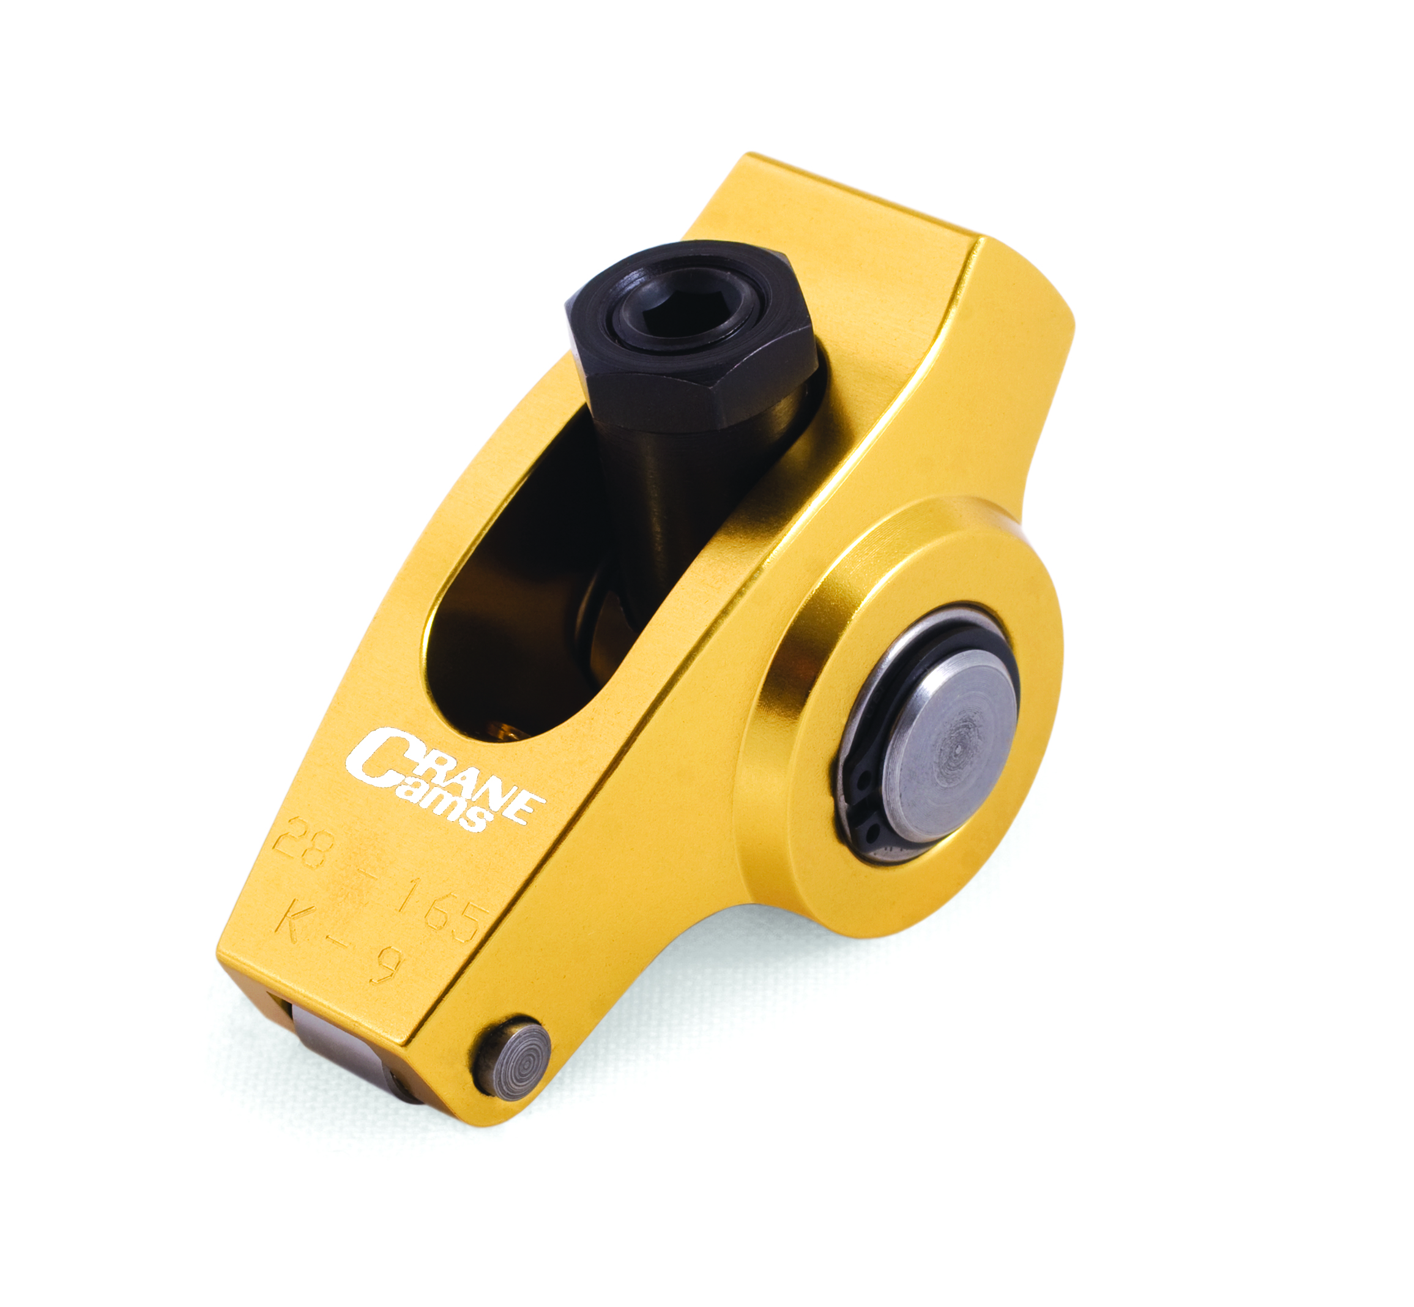

Download High-Resolution Image Files at AutoPressReleases.com

